**PROJECT ON**

**CENSONO**

**DEVELOPED BY**

**MATUR INNOCENT JOSHUA**

**C:\Users\MATUR EMMANUEL\Desktop\NIIT-Project\download\niit logo.png**

**CENSONO**

**Version** : V1.1

**Start Date** : December 22, 2022

**End Date** : January 15, 2023

**Name of Coordinator** : Mr. Fredrick

**Name of Developer** : Matur Innocent J.

**Date of Submission** : January 17, 2023

**C:\Users\MATUR EMMANUEL\Desktop\NIIT-Project\download\niit logo.png**

**CERTIFICATE**

This is to certify that this report titled Censono embodies the original work done by Matur Innocent Joshua in partial fulfillment of his course requirement at NIIT.

**Coordinator:**

Mr. Fredrick

**ACKNOWLEDGEMENT**

I have benefited a lot from the support, feedback and suggestions given to me by Mr. Fredrick and other faculty members. I wish to also acknowledge parent, siblings and fellow colleagues who have been sources of motivation to me throughout this project work.

**INTRODUCTION**

Censono is a chat website that enables it users to hold conversations between one another. The conversation can be a one-to-one conversation, one-to-many or many-to-many conversations. These conversations can be done either between two individuals (without third party access), or within multiple individuals as a discussion.

I decide to develop a website that will enable easy navigation and easy access to other users far from one another.

Censono can be used as a tool to connect and bring family, friends and people together.

**ACTIVITIES LIST**

The following tasks need to be performed to meet the specification of the project:

* Design web page layout to suit different dimensions.
* Design Navigation menus to provide access to other pages or contents of a page.
* Create forms to accept inputs from the user.
* Design navigation to the following pages in the header section if the home page of the website.
* Design a footer bar on the home page that displays the copyright information of the company.
* Optimize all the images used in the Web Pages.
* Create registration page, index.html where new users can register themselves in order to have access to the system.
* Create Login page, index.html to checkmate who is eligible to access the website’s chat section.
* Create chat page, messages.html to enable users to hold conversation between one another.
* Create profile page section, in messages.html to view and edit your profile information.
* Create chat friend profile page section in messages.html to view profile of the person you are chatting with.
* Create the home page, index.html, where users are taken first when they launch the website and provided with the login or register options. This page also contains navigation links to the following pages:
* Home
* About
* Contact
* Create Create the about page, about.html; to show information about Censono.
* Create the contact page, contact.html to show contact information of Censono.
* Create an external stylesheet to format all Web Pages of the Censono website.

**HTML PAGES**

Home/Login Page

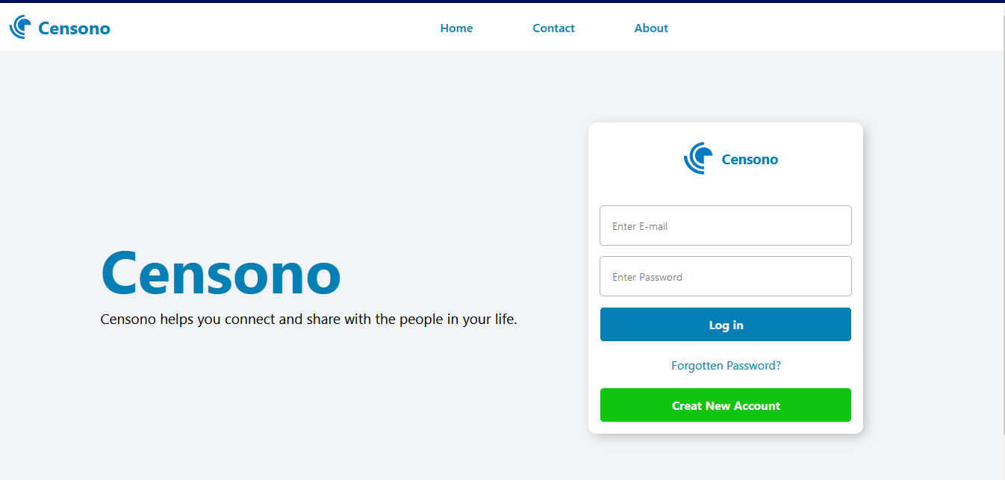

*index.html*

Registration Page

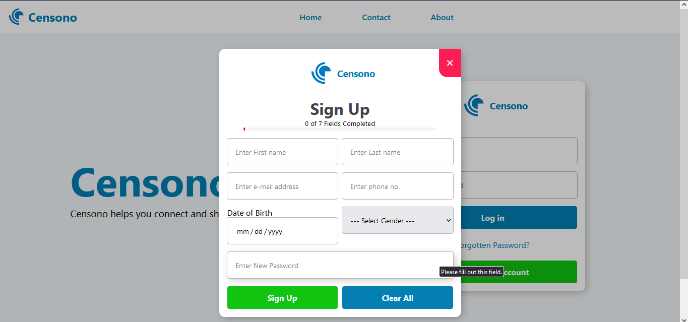

*index.html*

Chat messages page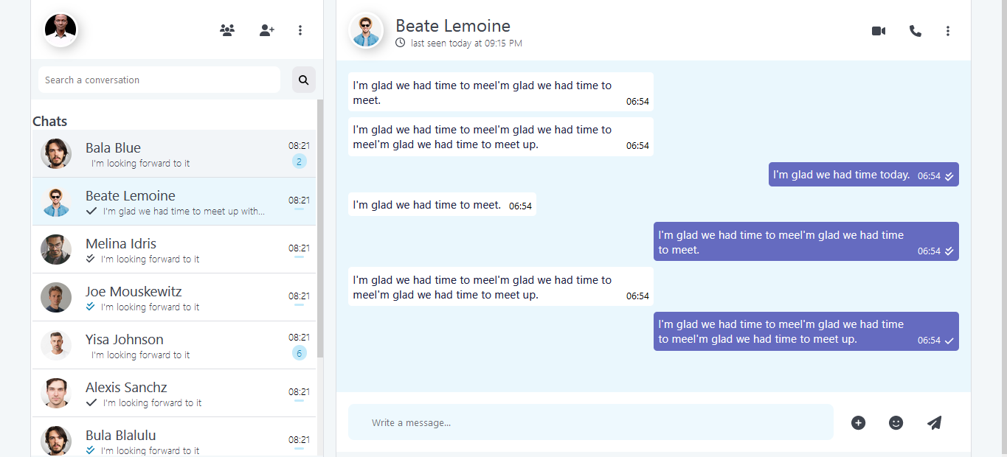

*messages.html*

My Profile Page

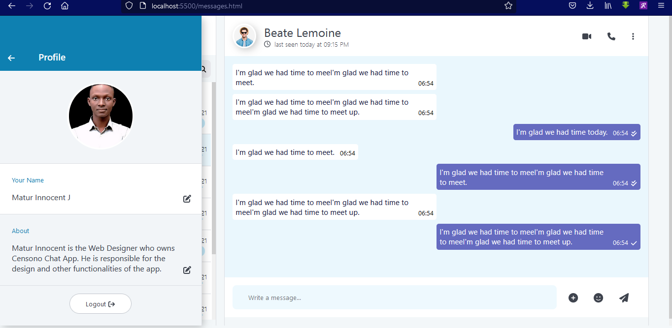

*messages.html*

User Profile Page

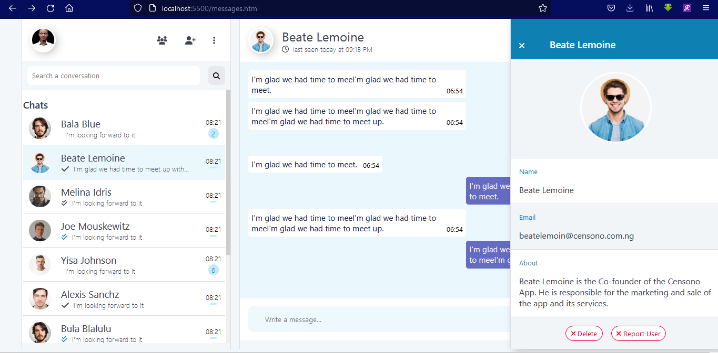

*messages.html*

My Profile and User Profile

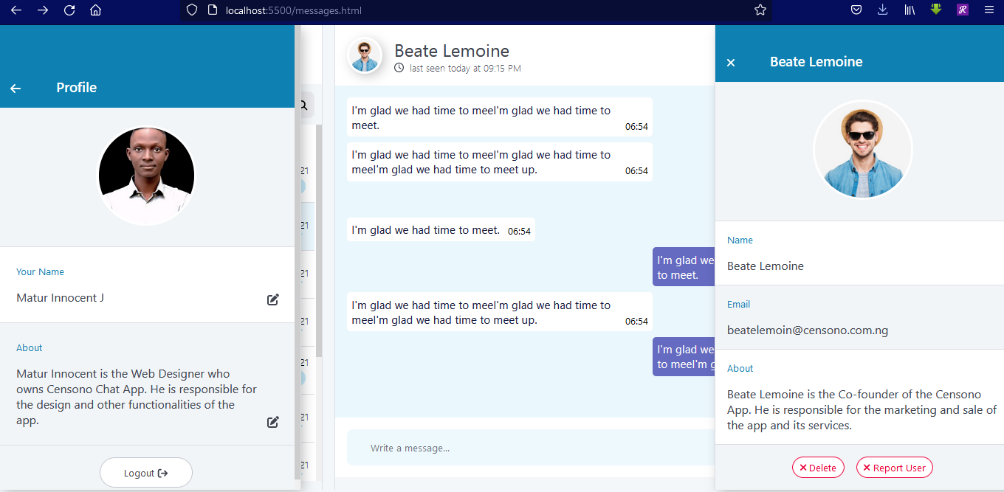

*messages.html*

Contact Page

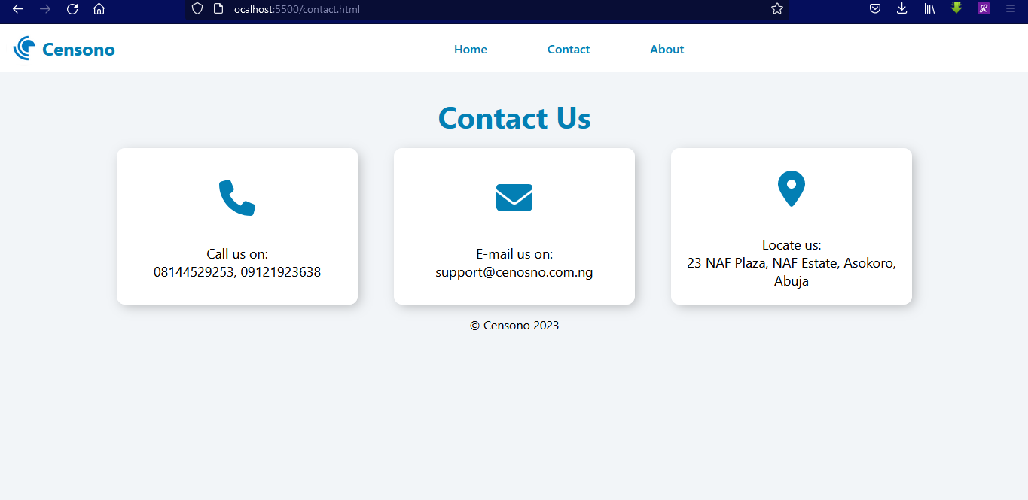

*contact.html*

About Page

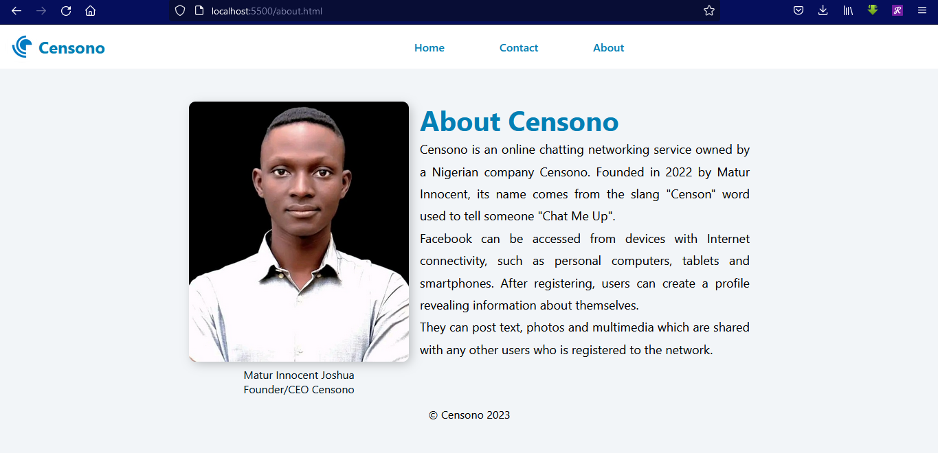

about.html

**JAVASCRIPT VALIDATIONS**

* The registration page uses JavaScript to validate and display to the user the progress of their registration
* After the user clicks the Plus (+) icon beside the input field, more options pop up.
* After the user clicks on their own profile picture at the top left of the page, their profile displays.
* When the user clicks on the picture (at the top) of who they are chatting with, the user’s profile opens.
* The user closes either of the profile pages by clicking the arrow left (🡨) button or the close (X) button at the top of the profile.
* After the user clicks on the register button, the registration form comes up.
* The user can click the close button at the top right of the registration form to close the form.
* JavaScript checks the registration form and indicates to the user if all the fields are filled or not.

**SYSTEM CONFIGURATION**

Hardware : 2.0 GHz Intel Pentium Processor or higher

: 2GB RAM or more

: 120GB Hard Drive or later

: Optical Wheel Mouse

: QWERTY Keyboard

: 15” Color Monitor

Operating System : Microsoft Windows 7 or later

Software : Mozilla Firefox Browser V16 or later

**PROJECT FILE DETAILS**

|  |  |  |
| --- | --- | --- |
| **S.No** | **Folder/File Name** | **Description** |
| 1 | images | Contains all images used for various web pages. |
| 2 | css | Contains all CSS and SCSS files used to style the web pages of the website. |
| 3 | js | Contains all JavaScript files used for the website’s pages functionality. |
| 4 | index.html | Contains the code to create the home page, login page and registration page of Censono.  This page also contains navigation links to the about and contact pages.  The file also contains the code for the footer of the website. |
| 5 | messages.html | Contains the code for the chat messages interface.  Contains the code for displaying the view “my profile” on the website.  Contains code for displaying the “user profile” on the Censono website. |
| 6 | styles.scss | Contains SCSS code for styling the **index.html** page of the Censono website. |
| 7 | styles.css | Contains the main CSS codes understandable to the browser for styling the **index.html** page, generated from **styles.scss** |
| 8 | mstyles.scss | Contains SCSS code for styling the **messages.html** page of the Censono website. |
| 9 | mstyles.css | Contains the main CSS codes understandable to the browser for styling the **messages.html** page, generated from **styles.scss** |
| 10 | all.min.css | Contains code for the icons used on the Censono website. |
| 11 | all.min.js | Contains supporting JavaScript code for icons on the Censono Website. |
| 12 | index.js | Contains the JavaScript code for adding more functionality to the **index.html** page. |
| 13 | mscript.js | Contains the JavaScript code for adding more functionality to the **messages.html** page. |
| 14 | readme.md | Contains the Censono Website information. |
| 15 | contact.html | Contains code for displaying contact information for Censono. |
| 16 | about.html | Contains code for displaying information of the about page of Censono website. |